**[F29DC 2024 Lab 4 –](https://canvas.hw.ac.uk/courses/28951/files/3694381?wrap=1" \o "F29DC 2024 Lab 1 - Connectivity, VPCs, Subnets, VLANs.pdf" \t "_blank) DHCP and NAT  
- Shyam Sundar Velmurugan  
- H00418621**

{Part 2}

DHCP Server

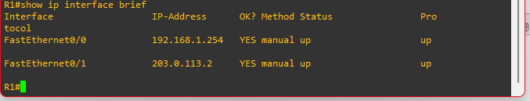

Image 2.1 : Using the show ip interface brief to check if we have provided the IP addresses correctly.

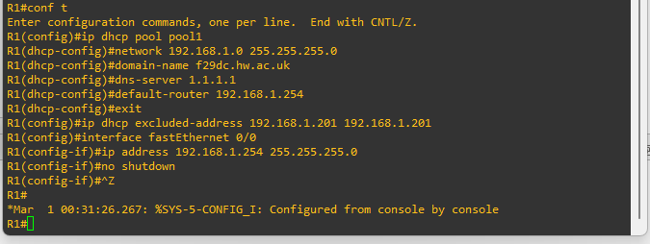

Image 2.2 : Entering configure mode and configuring network address via DHCP pool.

Then, Providing the ip address 192.168.1.0 255.255.255.0 and a domain-name called f29dc.hw.ac.uk.

Later, Setting up a dns-server with ip 1.1.1.1 and a default router with ip 192.168.1.254 and later exiting.

Finally, An DHCP excluded-address has been added with ip address 192.168.1.201 192.168.1.201. then we set up with a fast ethernet 0/0 with an ip address 192.168.1.254 255.255.255.0.



Image 2.3 : Checking the ip address and gateway using the command ip dhcp for PC2.

It uses the DORA process.

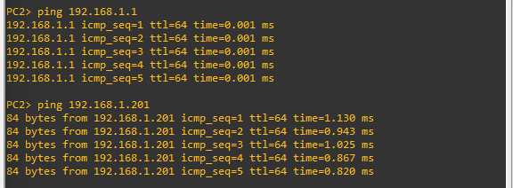

Image 2.4 : trying to ping both the ip addresses from PC2

192.168.1.1

192.168.1.201



Image 2.5 : Checking the ip address and gateway using the command ip dhcp for PC2.

It uses the DORA process.

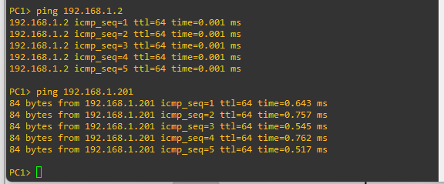

Image 2.6 : trying to ping both the ip addresses from PC1

192.168.1.2

192.168.1.201

------------------------------------------------------------------------------------------------------------------------------------------